DevelopersHub Corporation
Software Quality Assurance (SQA) – 3 Weeks Project
Week 1 – Manual Testing and Bug Reporting
Project Title: Bug Tracking and Test Automation for a Web Application
Student Name: Anam Saghir
Submission Date: 23 March 2026
System Under Test: SweetNSwirls – Android Ice-Cream Ordering Application Developed Myself Using Java & Xml
GitHub Repo Link: https://github.com/anam125/sweetnswirls

1. Introduction of the Application
SweetNSwirls is a native Android application developed using Java and XML in Android Studio. The purpose of the application is to allow users to browse different ice-cream desserts, add items to their cart, and place orders easily through a mobile interface.
The application uses SQLite database to store user data, cart items, and order information locally. This ensures that user information and order details remain saved even when the application is minimized or restarted.
The main goal of the application is to provide a simple and user-friendly interface for ordering desserts from a mobile device.

2. Main Features of SweetNSwirls
The application contains the following main features:
- User Signup using SQLite database
- User Login authentication
- Persistent user session
- Dessert menu display using RecyclerView
- Item detail screen
- Add to cart functionality
- Update and remove cart items
- Checkout and order placement
- Order confirmation and summary screen
These features were selected as the main modules for manual testing in this SQA task.

3. Software Development Life Cycle (SDLC)
Software Development Life Cycle (SDLC) is a structured process used to develop software systems in a systematic way. It ensures that software is built correctly and meets the required quality standards.
SDLC Phases
1. Requirement Analysis
In this phase, system requirements are collected and analyzed.
For the SweetNSwirls application, the main requirements include:
- User account creation
- Secure login
- Dessert browsing
- Cart management
- Order placement
Role of QA:
QA engineers review requirements to ensure they are clear and testable.

2. System Design
In this phase, the architecture and interface of the system are designed.
Examples in SweetNSwirls:
- Designing login and signup screens
- Designing the dessert menu layout
- Designing cart and checkout screens
QA ensures the design meets user requirements.

3. Development
Developers implement the application using programming languages and frameworks.
Technologies used in SweetNSwirls include:
- Java
- XML
- SQLite
- Android Studio
QA prepares test cases during this stage.

4. Testing
In this phase, testers verify whether the application works correctly.
Types of testing performed:
- Functional Testing
- UI Testing
- Navigation Testing
QA identifies bugs and reports them.

5. Deployment
After successful testing, the application is released.
QA performs final verification testing.

6. Maintenance
After release, updates and bug fixes are applied.
QA performs regression testing.

4. Software Testing Life Cycle (STLC)
Software Testing Life Cycle describes the process followed by QA engineers during testing.
STLC Phases
1. Requirement Analysis
Testers study application requirements and identify testable features.

2. Test Planning
Testing strategy and tools are selected.
For this project:
Test Case Tool → Google Sheets
Bug Tracking Tool → Jira

3. Test Case Development
Test cases are written for each feature.
Each test case contains:
- Test ID
- Test Description
- Preconditions
- Test Steps
- Expected Result
- Actual Result
- Status

4. Test Execution
Test cases are executed on the application.
Results are recorded as:
Pass / Fail.

5. Bug Reporting
If a test fails, it is recorded as a bug.
Bug reports include:
- Bug ID
- Description
- Severity
- Priority
- Steps to reproduce
- Status

6. Test Closure
Testing results are summarized in a report.

5. Manual Testing Process for SweetNSwirls
The following modules were selected for testing:
- Signup
- Login
- Dessert Menu
- Add to Cart
- Cart Management
- Checkout and Order Placement

6. Writing Test Cases using Google Sheets:
Test cases were created using Google Sheets.
Steps to create test cases:
- Open Google Sheets
- Create a new sheet
- Create the following columns:
| Test ID | Test Description | Preconditions | Test Steps | Expected Result | Actual Result | Status |
Example Test Cases
Test ID | Test Description | Preconditions | Test Steps | Expected Result | Actual Result | Status
TC-01 | Verify signup with valid details | Signup screen open | Enter valid details and click signup | Account created successfully | Account created | Pass
TC-02 | Verify signup with empty fields | Signup screen open | Leave fields empty and click signup | Validation message should appear | No validation message | Fail
TC-03 | Verify login with valid credentials | Account exists | Enter correct email and password | User logged in | Login successful | Pass
TC-04 | Verify login with wrong password | Account exists | Enter wrong password | Error message should appear | No error message | Fail
TC-05 | Verify dessert menu display | User logged in | Navigate to menu screen | Desserts displayed correctly | Menu visible | Pass
TC-06 | Verify add to cart | Menu screen open | Select item and click add to cart | Item added to cart | Item added | Pass
TC-07 | Verify remove cart item | Cart contains items | Click remove button | Item removed | Item removed | Pass
TC-08 | Verify checkout process | Cart contains items | Click checkout | Order confirmation screen appears | Order confirmed | Pass

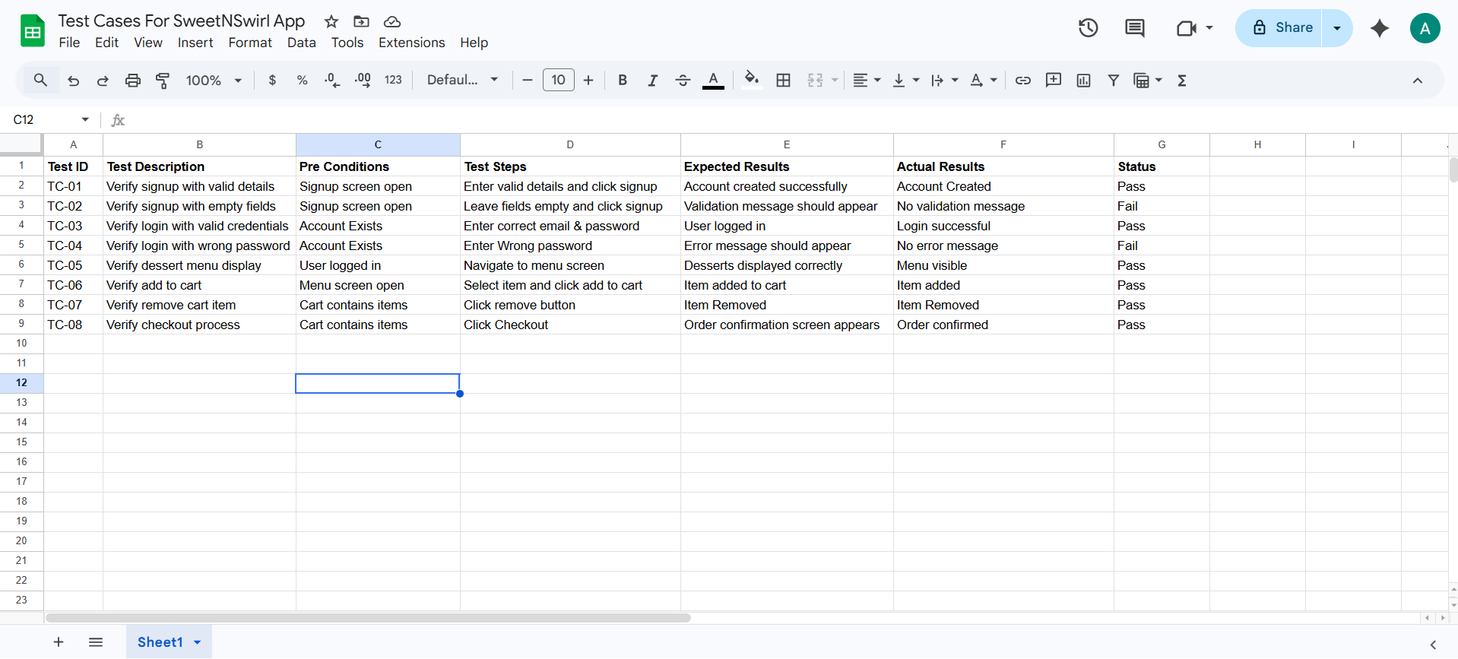
Screenshot Section:

7. Bug Reporting using Jira
Bug tracking was performed using
Jira.
Jira is a professional tool used by software companies to track software issues.

Steps to Create Bug Reports in Jira
- Open Jira website
- Create a new project
- Select Bug Tracking Template
- Click Create Issue
- Select Bug Issue Type
- Fill the bug details

Bug Report Fields in Jira
Each bug report includes:
- Bug ID
- Summary
- Description
- Severity
- Priority
- Steps to reproduce
- Status

Example Bug Reports
Bug ID | Description | Severity | Priority | Steps to Reproduce | Status
BUG-01 | Signup allows empty fields | High | High | Open signup → leave fields empty → click signup | Open
BUG-02 | Login does not show error for wrong password | Medium | High | Enter wrong password → click login | Open
BUG-03 | Cart icon does not update item count | Medium | Medium | Add item to cart | Open
BUG-04 | Checkout button alignment issue | Low | Low | Open cart screen | Open
BUG-05 | Menu images load slowly | Low | Low | Open menu screen | Open

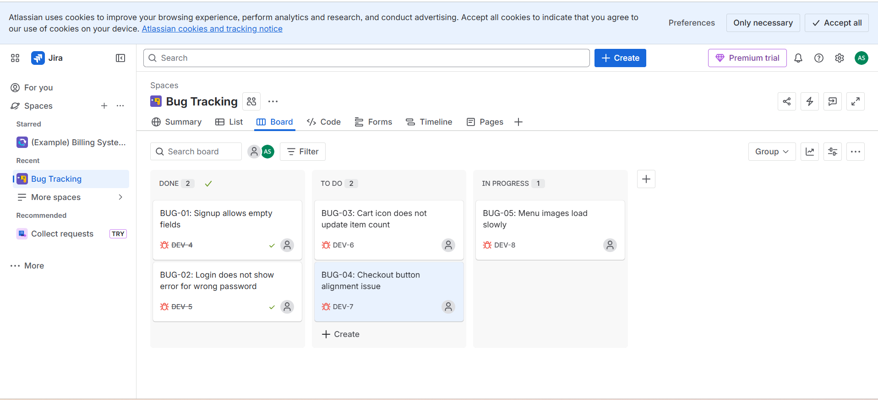
Screenshot Section:

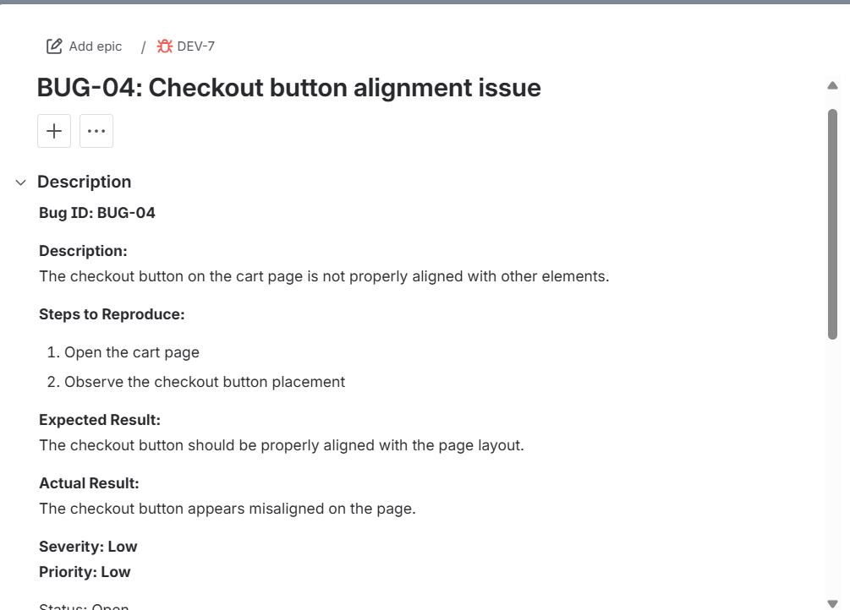

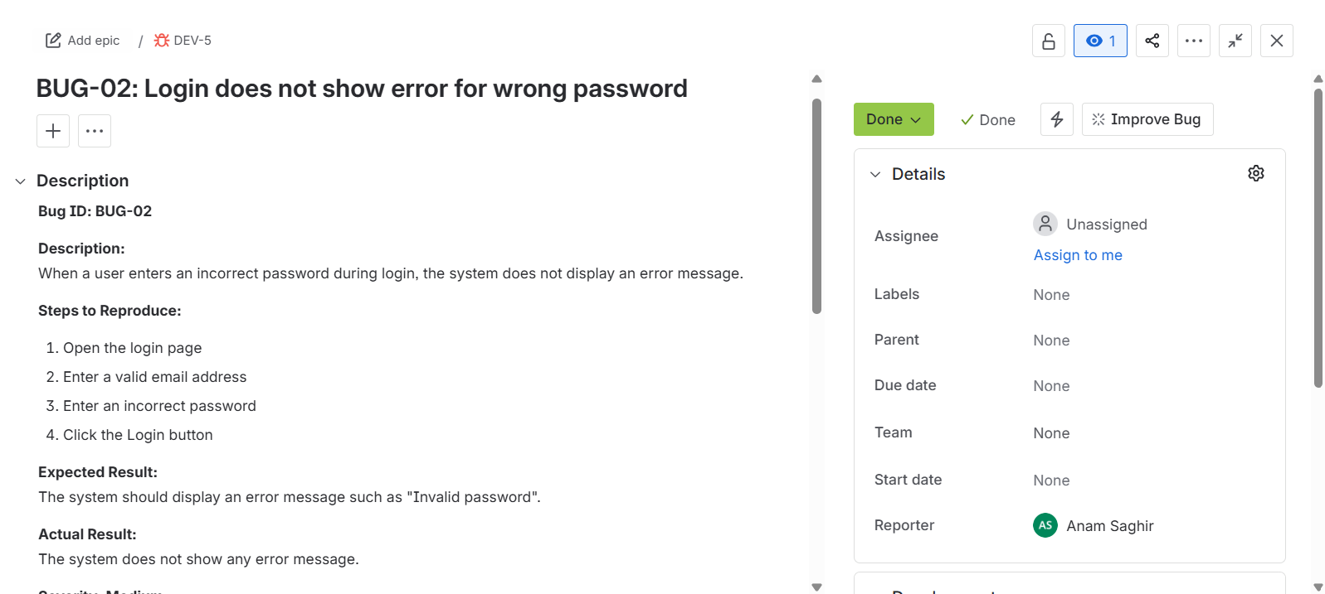

8. Test Environment
The testing environment used for the SweetNSwirls application includes:
Operating System: Android
Development Tool: Android Studio
Programming Language: Java & Xml
Database: SQLite
Testing Type: Manual Testing

9. Conclusion
Manual testing of the SweetNSwirls application was successfully performed to evaluate its functionality and usability. Test cases were designed and executed using Google Sheets, and potential issues were documented using Jira bug tracking system. This testing process helped ensure that important features such as login, signup, menu display, cart management, and order placement work correctly and provide a smooth user experience.

